|  |
| --- |
|  |
| Mobile Image Processing |
| Final Report |
|  |
| **Hamed Ordibehesht** |
| **Autumn 2009** |

|  |
| --- |
| The purpose of this report is to explain the project of Mobile Image Processing. This report identifies the outcomes of the project. The goal of this project is to prove the core idea of using image processing techniques to recognize and interpret UML standard diagrams drawn by hand. It mainly describes our novel image processing algorithm designed for recognition of the elements of a digital photo of a class diagram drawn by hand over a white board. Additionally, it explains the process of research and development of the algorithm. |

Table of Contents

Abstract 2

Introduction 2

Previous Works 2

Project Process 3

Project Description 4

Project Assumption and Constraints 4

The Project Outcome 5

1. Pre-Processing Step 5

1.1. Noise Elimination 6

1.2. Edge Detection 8

1.3. Shape Refinement 9

2. BLOB (Binary Large Object) Detection 10

3. Feature Recognition 11

Conclusions 12

References 13

# Abstract

The purpose of this report is to explain the project of Mobile Image Processing. This report identifies the outcomes of the project. The goal of this project is to prove the core idea of using image processing techniques to recognize and interpret UML standard diagrams drawing by hand. It mainly describes our novel image processing algorithm designed for recognition of the elements of a digital photo of a class diagram drawn by hand over a white board. Additionally, it explains the process of research and development of the algorithm.

# Introduction

Computer has affected many aspects of our lives. From simplifying the office works to automation of the tasks in a nuclear reactor. As a human wish to create robots that can full fill tasks exactly as how a man could do, researchers have developed the hardware, software, techniques, algorithms, and machines that each of them has realized one or some portion of this great wish. Among these abilities handling the tasks, making computer systems, such as robots, being aware of the environment in order to react has been a great research field.

As it is known Computer Vision is the science and technology of computational machines to see[1]. One of the rapidly growing research areas of this field is recognition of hand writings and drawings. There have been many great researches and attempts to develop the systems that can recognize the features or elements of a hand drawing from a digital photo and interpret the meaning that each feature carries in its specific domain. For example, recognition of a rectangle from a picture and interpret it as it is a rectangle drawing or it is part of a bigger shape such as a building!

The goal of this project is a proof of concept idea. This idea is to assess the feasibility of using advanced image processing techniques for recognition of UML standard diagram's elements from a hand drawn diagram. Here in this project, we have investigated and developed a prototype of the system that recognizes features of a hand drawn class diagram. This system is able to recognize class diagram elements such as classes and relations from a digital photo of a hand drawn diagram. The application of this system is vast. The main considered application is a quick and dirty way of getting an early indication of certain characteristics of the designed class diagram. These characteristics can be indicated by collecting the simple metrics such as Structural Complexity. The input to these metrics is the recognized classes and relations from a hand drawn diagram over a white-board.

# Previous Works

Throughout our research project, we have investigated the area of Computer Vision research, specifically image processing and recognition of hand drawings. As a result a found fact is that this area is categorized in two major research sub-areas:

* Online sketch recognition
* Offline sketch recognition

Online Sketch Recognition means that the image processing technology and steps is done throughout and in parallel with the process of drawing. It starts from the time the person starts using the pen and stops when the person finishes the drawing. For this category, many techniques are developed that appeal specific hardware such as Laser Pen, or Tablet PC.

On the other hand, Offline Sketch Recognition is the image processing technology of recognition of the drawing only by processing the untouched digital photo of it. In this case, the absence of some very useful and effective data in contrast with Online Sketch Recognition, such as pen strokes and sequence of drawing, complicates the process. The image processing of this category is very different and in some domains much more complex in comparison to the Online Sketch Recognition.

Comparison of researches and developments in these two distinctive areas shows that the focus has been more on the Online Sketch Recognition. There have been many techniques and tools developed for solving the problems in this area. In contrast, despite many works on the Offline Sketch Recognition, this area still lacks of successful and widely applicable solutions. Especially in the sub-area of hand drawing recognition, the last and somehow successful technique for recognition of structural diagrams was done in 2004 [1].

Knowing the lack of enough works on proving the concept of offline recognition of hand drawn diagrams of UML standard, this project is a great progress towards a complete and realistic computer visionary system.

# Project Process

The process of the project was research and prototype development. In order to identify the scope of the project, aims and objectives, and expected outcome, a project plan was created. The tasks were identified and a time plan was created.

Basically, the aim of the project is proof of concept idea to see whether it is possible to use advanced image processing techniques to recognize hand drawn diagrams that comply with UML standards. The idea is to use advance image processing techniques for recognition of a hand drawn class diagram's elements. The technique is to be developed as a cell-phone application that can be used instantly to take a digital photo from a hand drawing of a class diagram over a whiteboard.

For this purpose the main objective of the project is to create an image processing algorithm for the recognition of a hand drawing. As the second objective, the created algorithm will be developed into a mobile tool in the first prototype for assessing the possibility of the idea.

As a result, this project aims to answer the following research question:

Is it possible to use advanced image processing techniques to recognize and interpret the features of a hand drawn class diagram?

The second research question is:

Can found algorithm or technique be used to develop a quick and dirty way of getting early indication of certain characteristics of the design by collection of some simple metrics such as structural Complexity?

With the supervisory of Dr. Miroslaw Staron, the scope was defined and the assumptions were made which are explained in the section Project Assumptions and Constraints; however, the scope of the project has been refined since the initial plan.

# Project Description

The project is to develop a prototype of a tool for Symbian cell-phone. The functionality of this tool is to collect structural complexity metric of a hand drawn class diagram. The structural complexity of a class diagram is specified by the following metric:

**Structural Complexity (SC) = Number of Classes**

The diagram is drawn by hand an over a whiteboard. The photo is taken by a Nokia 5800’s camera. In the first phase of the project, the algorithm is designed, assessed, and improved in MATLAB. The Image Processing Toolbox included in the MATLAB is used for performing image processing operations. The second phase is to develop a prototype tool from the developed algorithm. The prototype will be developed and deployed on Nokia 5800 with Symbian OS.

## Project Assumption and Constraints

As hand drawings vary significantly depending on the person and the environment, some assumptions are made for the project. These assumptions are listed below:

* The person follows a consistent drawing style. It means that the sketcher has to be careful about the size, style, angle, etc. of each drawing feature to be consistent.
* Rectangular class elements are big enough to be recognized by the process. Small rectangles would be counted as noises, consequently deleted automatically in the Pre-processing step.
* Distinguish colors are being used for drawing.
* Whiteboard is used for the drawing purpose.
* The drawing does not contain any textual elements.
* The drawer only uses horizontal or vertical lines.
* The photo is taken by Nokia 5800 digital camera set to the best quality.
* The photo only contains the whiteboard area.
* The photo is not touched.
* The photo is taken in the normal lighting condition of a room. The light and spot reflections are not captured in the photo.

# The Project Outcome

As a result of the project, a novel algorithm is developed. The created algorithm is divided into three main steps as shown in the figure 1:

1. Pre-processing
2. BLOB Detection
3. Feature Recognition

Figure 1. Image processing steps

The steps are explained in detail throughout the following sub-sections.

## Pre-Processing Step

The Pre-processing step is to provide a sampled image of the initial photo. This sampled image contains only needed data for the second step which is BLOB Detection. In this step, noises are eliminated, and shapes of the drawings are found and refined. The pre-processing step is done through five sub-steps in which the input of the latter is the output of the former sub-step. The figure 2 illustrates the Pre-processing steps in sequence and detail:

Figure 2. Pre-processing steps

### Noise Elimination

Basically noise in a digital photo is the data that is unwanted or exists due to the malfunction or error that is introduced to the image by the image acquisition device [1].  For the purpose of eliminating the noises, the first three steps are used which significantly reduce the noises introduced by the cell-phone's camera. The noise elimination algorithm is a state-of-the-art. This novel algorithm is developed by applying a combination of a sequence of three simple filters on the initial digital image:

1. Symmetric Gaussian Lowpass Filter
2. Grayscaling
3. Resizing

As given by [1], we chose to use symmetric Gaussian lowpass filter for the first step of noise reduction. The optimal filter size and sigma value are determined empirically by examining the result on different sample photos captured by a Nokia 5800’s camera. The size of filter is 15*15 and Sigma value is 10. The figure 3 shows a sample digital photo taken by a Nokia 5800’s camera whereas the figure 4 shows the output of filtered image using symmetric Gaussian lowpass.

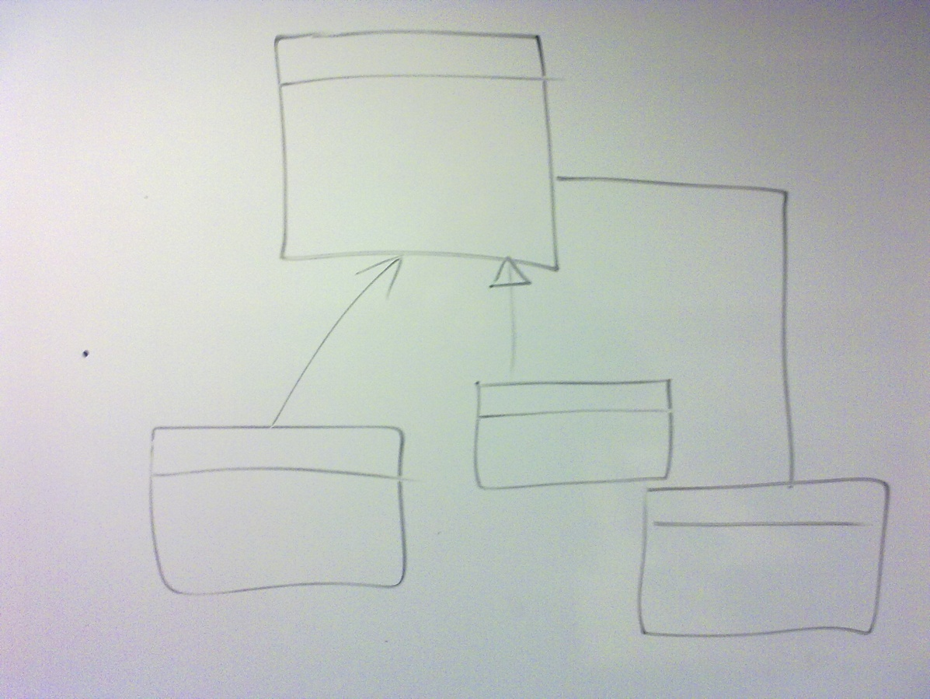

Figure 3. Sample digital photo captured by Nokia 5800 digital camera from a white-board

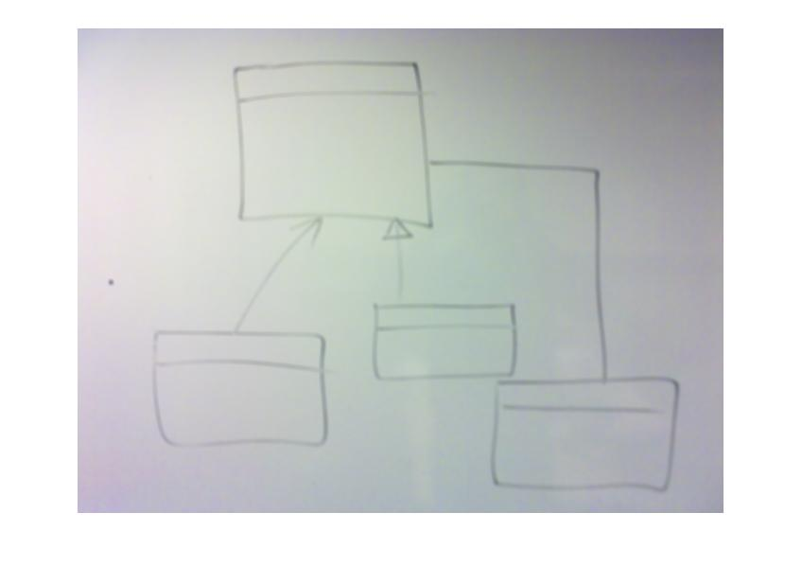

Figure 4. Applied symmetric Gaussian lowpass filter

Furthermore, as we are not concerned about the colors in this project, a gray scaling filter is used in the second step. This filter provides an output image from the previous step. This output image is representation of the input image where each pixel carries the information about the light intensity of that pixel in the original image. In the figure 5 the output of this step is illustrated.

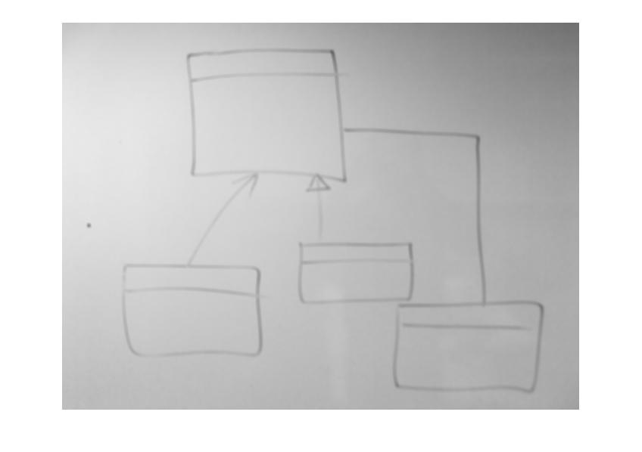

Figure 5. Gray scaled image

Finally, the last step of the noise elimination process is to shrink the image. Shrinking the image output from the previous step using a Bi-cubic Interpolation filter by the scale factor of 60 percent significantly eliminates the many of the remaining noises. The scale factor and filter for resizing the photo is determined empirically. The figure 6 shows the output of this step.

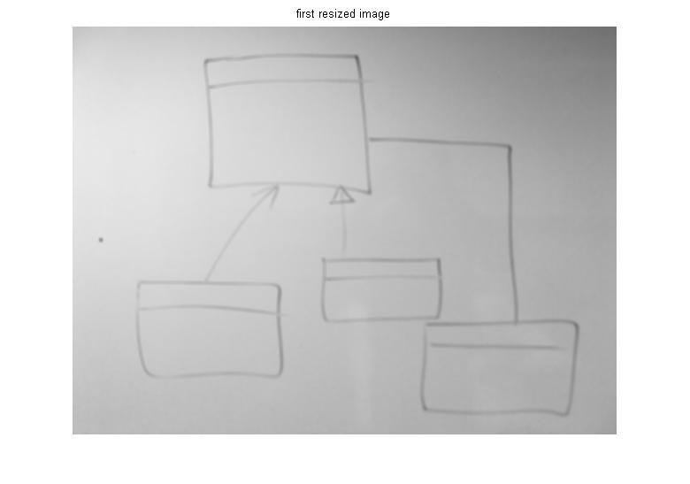

Figure 6. Shrunk image

### Edge Detection

Finding the edges in an image is the first step towards finding objects in a drawing. For this purpose, edges are detected from the image output of the previous step. The edge detection step uses Sobel operator for calculation of the threshold value. Further on, Sobel Edge Detection method with the calculated threshold value is applied to the image output of the previous step. The output of Edge Detection step is a black-and-white image where detected edge's pixels are identified by 1 (white) and the rest of the pixels by 0 (black). A sample output of this step is shown in the figure 7. (This figure contains only a small region of the original output.)

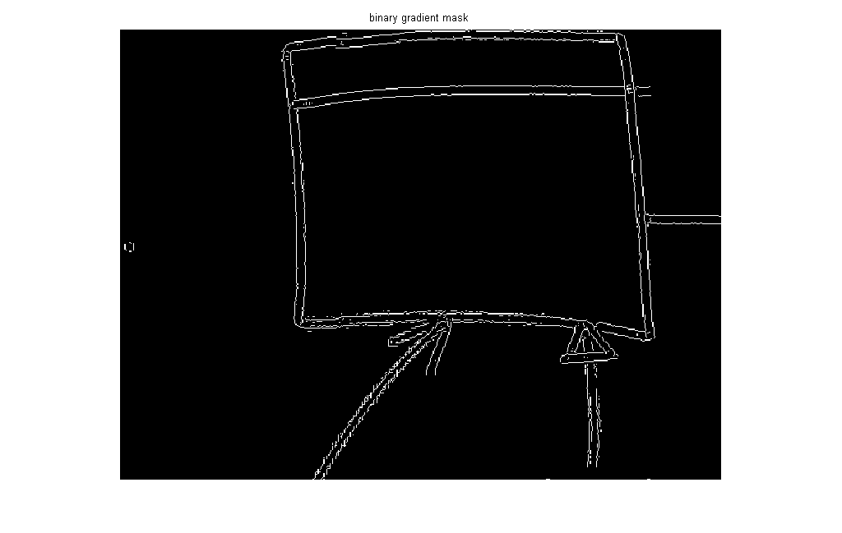

Figure 7. Edge Detection output

For the purpose of comparison, an image without noise elimination step is processed with the edge detection step which is shown in the figure 8. Comparing the result of these two (noise elimination plus edge detection in the figure 7 and non-noise elimination edge detection in the figure 8) clearly illustrates the great effect of our designed noise elimination algorithm.

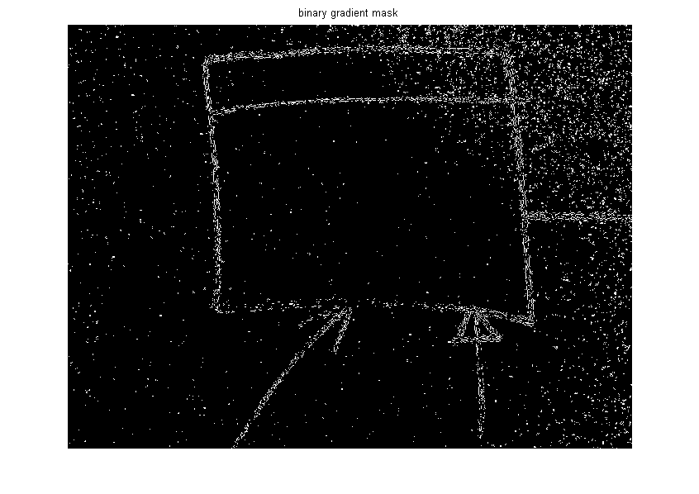

Figure 8. Edge Detection output without noise elimination

### Shape Refinement

People tend to use different styles while drawing. Some may draw rectangles with just one pen stroke while some others may use one pen stroke for drawing each side of a rectangle. As a result, sometime there happens that a drawn rectangle has open corners. As our process uses BLOB Detection for detecting a rectangle as a filled area, it becomes an implicit rule that the drawn rectangles have to be complete and closed. Therefore, in the Shape Refinement step, the drawn shapes are refined from the output of the Edge Detection step in order to produce a photo that is fully qualified for detection of the drawing’s objects. In order to refine the shapes, two morphological operations are applied subsequently to the image output from the previous step.

The first operation is Dilation by a cross (combination of horizontal and vertical line) kernel with the size of 3*3. Simply, this operation will thicken the found edges 3 times in both horizontal and vertical directions. The second operation is Closing. This operation is a combination of subsequent Dilation and Erosion morphological operations. A square kernel with the size of 30*30 which is determined empirically by examining the result on different sample images is specified for the Closing operation.

In the figure 9, an output of the Shape Refinement step is illustrated. This figure shows the output of the whole Pre-processing step as well.

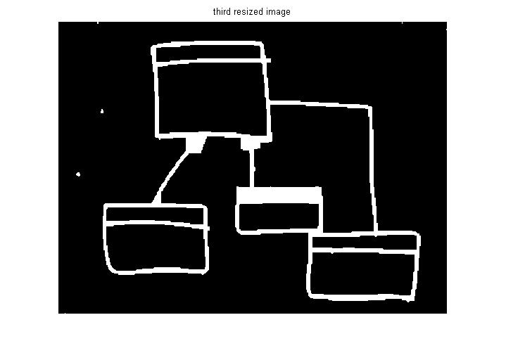

Figure 9. Pre-processing step output

## BLOB (Binary Large Object) Detection

According to [2], BLOB (Binary Large Object) is a region of interest in an image. The process of finding BLOBs from an image is called BLOB Detection. BLOB Detection is used as the main step of detection of the class diagram’s elements from the pre-processed image. BLOB Detection step in our project includes three steps which are listed and shown in the figure 10. As it is shown, the input of the BLOB Detection step is the output of the Pre-processing step. The output of each sub-step in the BLOB Detection process is the input of the subsequent sub-step by the order shown in the figure 10. The output of the BLOB Detection process is the input of the Feature Recognition step which is explained in the section Feature Recognition.

Figure 10. BLOB Detection steps

The first step of BLOB Detection is finding connected components from the black-and-white image. The connected components are found by tracing all eight neighbors of each pixel and see whether they are white or not. If a neighbor pixel is white, it will be added to the same component. If not, it will be categorized as a new component.

In order to simplify the detection of the features, Labeling technique is used. Labeling the components in our project helps segmentation of the image. Afterwards, by calculation of the bounding box for each labeled component, the image is segmented into regions of which will be used in the Feature Recognition step. The output of BLOB Detection step from the sample image in the figure 1 is shown in the figure 11.

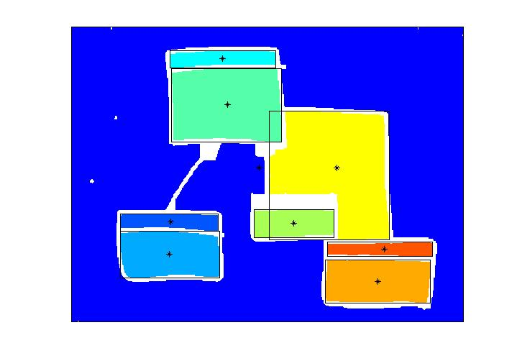

Figure 11. BLOB Detection step output

## Feature Recognition

The output of the BLOB Detection step is a set of components. Each component is not necessarily a class diagram’s element. It could be an uneliminated noise or a closed region formed by two relations between two classes on the diagram. Hence, a recognition process has to be applied to the segmented regions in order to find the features of interest which are classes.

According to mentioned assumptions in the section Project Assumptions and Dependencies, by using some domain specific heuristic we can filter out uninteresting features and miscalculations. As the domain of this project focuses on class diagrams complied with UML standard, following heuristics are considered:

* Class elements do not intersect
* Class element’s width ~> height
* Class element’s region is shared in maximum of two segments which intersect or align horizontally

There are other heuristics that help filtering out some other segments that are not of our interest:

* A segment that is the size of the image is not a class element

When all the domain heuristics are considered, the reminding segments determine the class elements. As a result the number of class elements is used to calculate the Structural Complexity metric.

# Conclusions

Computer Vision as an interesting science has attracted many researchers. Despite a large amount of researches and developments in this area, the Offline Sketch Recognition still lacks from complete and advanced solutions that could answer common real-life problems comprehensively. Hence, this project is done based on a proof of concept idea to show that it is possible to use advanced image processing techniques to recognize class diagram elements from a hand drawn diagram over a white-board.

Throughout this project, after investigating the area of Computer Vision and Image Processing, an algorithm is designed and developed to illustrate the power of image processing for solving an existing applied IT. The algorithm is implemented in MATLAB.

Furthermore, as part of the designed algorithm, noise elimination process by combination of a Gaussian filter, gray scaling, and shrinking is a novel approach which significantly reduces the noise and unwanted data from a digital image while keeping the detail in of the image in a high level. The noise elimination algorithm works independent of different luminance existing on the image. This fact enables the image processing processes to work on broader range of images taken in different environmental conditions. It is also fast and reliable enough to be utilized in real-time image processing.

On the other hand, metrics collection result is not accurate enough. Our investigation shows that more than 30 percent of the experiments have slightly wrong result. This is due to the incomplete feature recognition process. We aim to improve feature recognition in the future to get better and accurate results.

We learned new lessons from this project. First of all, it is important to keep track of time and effort even in research projects with small number of researchers in the team. Furthermore, MATLAB tool is one of the best tools to help developing the algorithms, diagnosis, and modifications. It is easy to use and simple to learn. It also includes an Image Processing Toolbox which is a complete set of off the shelf filters, operations, and functions for image processing.

For the next step, after improving the feature recognition process, a prototype of the application on Symbian OS has to be developed. This prototype will be used to assess the efficiency of the tool and the accuracy of its result. In order to improve the algorithm, the Thinning method explained in [3] can be used to have more exact boundaries. This way, the segmentation will be more accurate, and path tracking can be used in order to recognize rectangular features.

# References

1. Notowidigdo, J., M. 2004. User-Directed Sketch Interpretation. Master thesis submitted to *Department of Electrical Engineering and Computer Science*, Massachusetts Institute of Technology.
2. Danker, A., J., Rosenfeld, A. 1981. Blob Detection by relaxation. *IEEE Trans. Patt. Anal. Mach. Intell.*, Vol. PAMI-3, No. 1, 79-92, 1981.
3. Nedzved, A., Ablameyko, S., and Uchida, S. 2006. Gray-scale thinning by using a pseudo-distance map. In *Proceedings of the 18th international Conference on Pattern Recognition - Volume 02* (August 20 - 24, 2006). ICPR. IEEE Computer Society, Washington, DC, 239-242. DOI= <http://dx.doi.org/10.1109/ICPR.2006.618>.
4. Notowidigdo, M., Miller, RC. 2004. Off-line sketch interpretation. In *Proceedings of AAAI fall symposium series 2004: Making pen-based interaction intelligent and natural*. 2004. 120-126.
5. Boiangiu, C. and Raducanu, B. 2008. Robust line detection methods. In *Proceedings of the 9th WSEAS international Conference on international Conference on Automation and information* (Bucharest, Romania, June 24 - 26, 2008). L. Vladareanu, V. Chiroiu, P. Bratu, and I. Magheti, Eds. Recent Advances In Electrical Engineering. World Scientific and Engineering Academy and Society (WSEAS), Stevens Point, Wisconsin, 464-467.
6. Hamarneh, G., Althoff, K., Abu-Gharbieh, R. 1999. Automated Line Detection. Project Report submitted to *Department of Signals and Systems*, Chalmers University of Technology.
7. Ouyang, T. Y. and Davis, R. 2007. Recognition of hand drawn chemical diagrams. In *Proceedings of the 22nd National Conference on Artificial intelligence - Volume 1* (Vancouver, British Columbia, Canada, July 22 - 26, 2007). A. Cohn, Ed. Aaai Conference On Artificial Intelligence. AAAI Press, 846-851.

1. <http://en.wikipedia.org/wiki/Computer_vision>